Monthly Report /#1

- Date of Report:1/7-31/7
- Student ID - Name: Mohammad Hani Alshenaiwer
- Major: Cybersecurity
- Company: Arab Bank
- Department: Security Insurance
- Industry Mentor: Sari Abu Qoura
- Apprenticeship Mentor: Shareef Shargawi
- Working days/hours:5 days a week / 7:30 hours
Your report must cover these topics:
- Your role and responsibilities this month (+ evidence)
For the first month I entered the security assurance team and kept finishing tasks that the team leader gave so I can be familiar with the tools and the environments that security assurance team with so for a starter I worked with FastAPI creating multiple code that provide simple GET and POST API like a an code that have POST API to write item and a get API to show the list of items and downloaded postman tool to use it to access APIs without having a full functional code 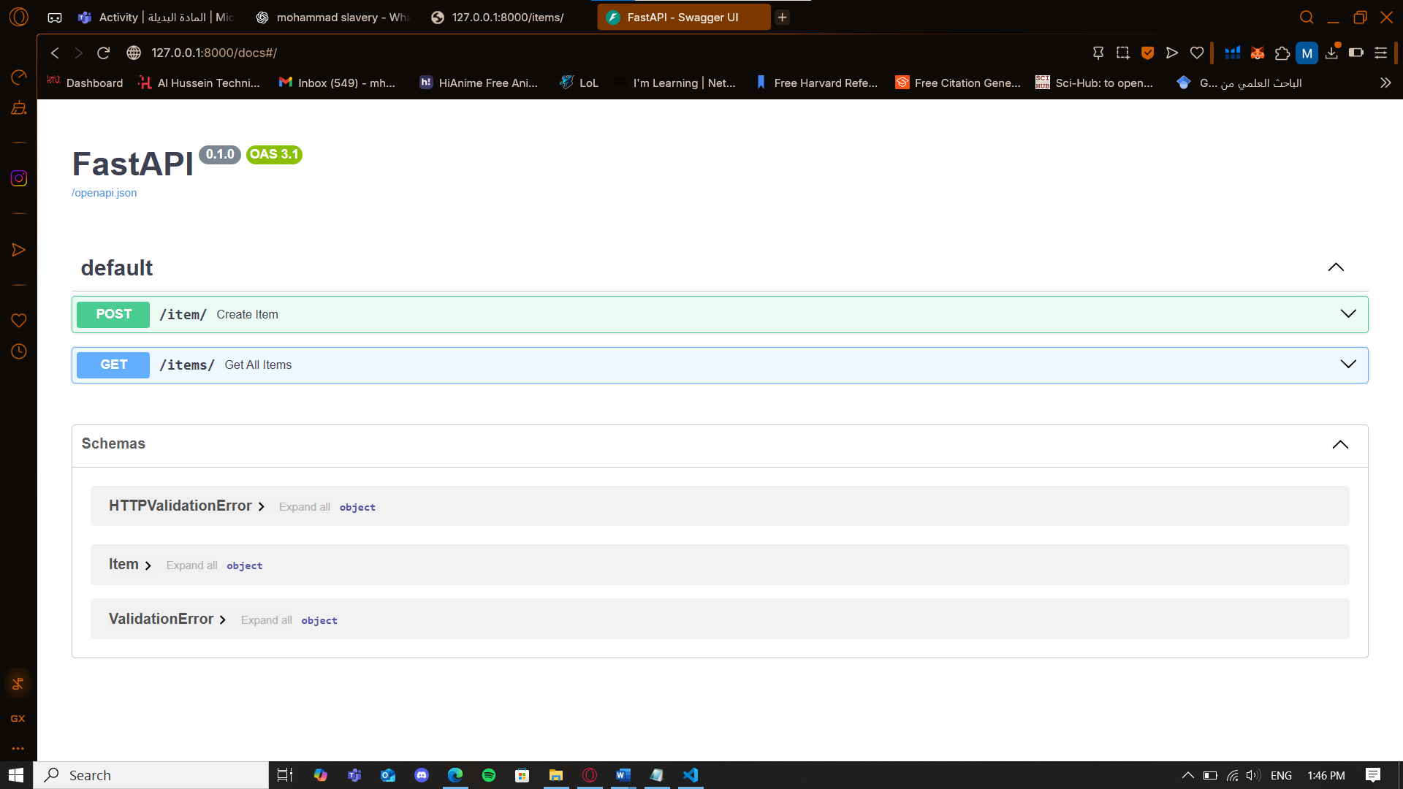
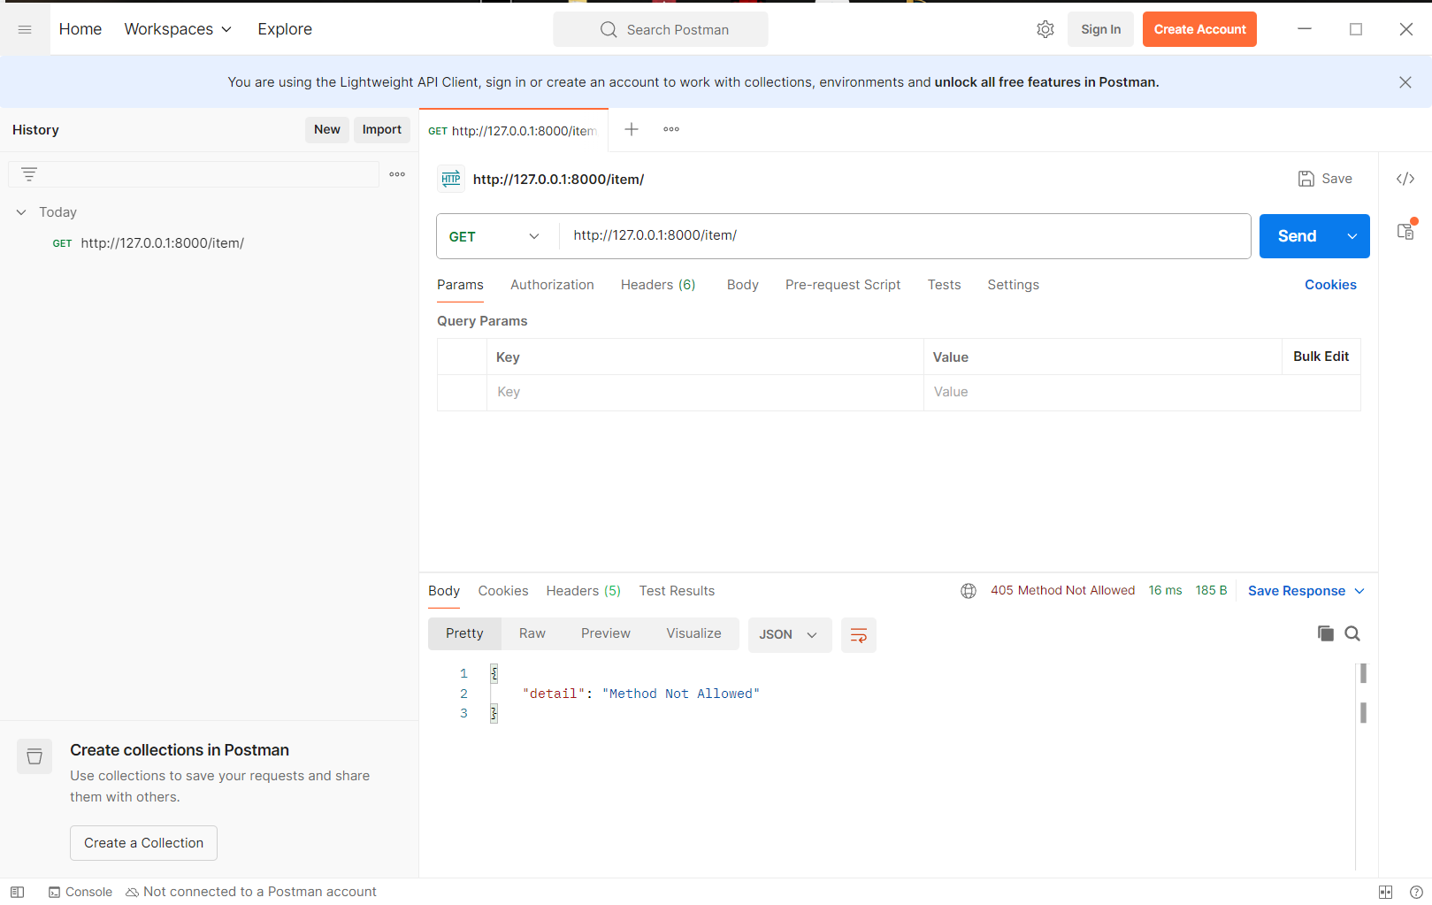
After coding some codes the team showed explained to us how they use these tools in their operations
- Any problems / Challenges and how did you overcome them?
- Did not face any problems since the task was only to introduce us to the tools that the team uses for their operations
- Any training courses you attended during the apprenticeship, whether you opted for independently or through the employer.
  - Name of the course
  - Main Topics
  - Copy of certification
No courses were required in this month

- What software /tools did you use?
- Venv: environment to download the tools in VS code
- FastAPI to run the python codes that contains GET POST API in the localhost
- Postman: to access the APIs in a GUI platform
- Technical and non-technical skills
- API writing in python

- Did you work on the National Occupational Standards (NOSs):
  - How many NOSs did you complete out of 5?
  - List of NOSs (Number (URN) – Name of NOS)
did not work in NOS in this month

- Events / Conferences you participated

- Your Plan for Next Month.
Doing the exercises that the team leader gives us until I receive access to the system

